RJ Cable

RJ abbreviated for the **Registered Jack**. It used as a medium in telecommunications or network interface. It enables network devices to connect voice and data equipment. It is mainly used to connect different types of data equipment and telecommunication media to take services offered by the local services provider to exchange data for longer distances and shorter exchange carriers. These RJ cables are categorised on the basis of structure and functions, such as size, PIN number, and their reliability on different devices.

Types of RJ

There are following types of RJ cable used in telephone line and to connect and share data among the connected systems.

* RJ11
* RJ11-W
* RJ14
* RJ21RJ25
* RJ45
* RJ48
* RJ61

RJ11

It stands for the Registered Jack11, containing a four-wire or six-wire telephone-type connector to connect telephones to wall plates. However, it supports up to six-wire; most of the old wired telephone lines use twisted-pair cables with four wires to connect to ISPs (Internet Service providers).

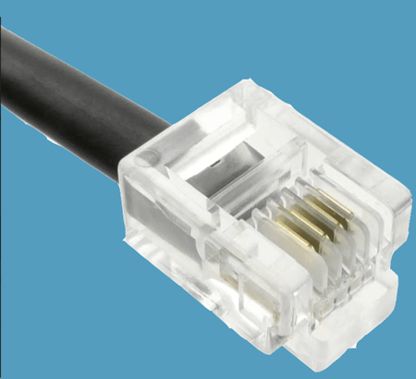

RJ11-W

It is the RJ11-W, where the W denotes the wall mount. It is an extended version of the RJ11. It is used to create bridge connections to the telephone lines with various wall mount functionalities.

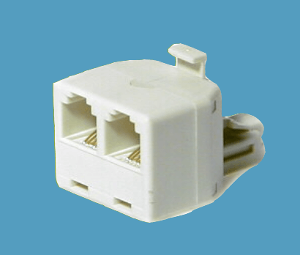

RJ14

It is a standard connector that uses 6P4C, i.e., six positions, four contacts modular connector. It is similar to RJ11 except that it uses two telephone cable lines and can be used as a modem connector in a computer.

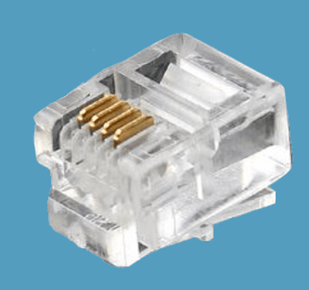

RJ21

It is a registered jack 21 designed with 50 conductors in such a way that it can handle 25 telephone lines simultaneously. It is mostly used in wide networks to operate in an organization with multiple switches and devices.

RJ25

It is a standard connector RJ25 that uses a 6P6C, six positions, six contacts modular connector. These modular plugs are used to connect three lines of telephone cable connectors.

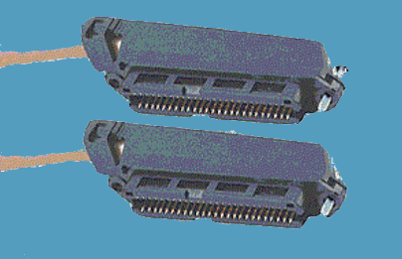

RJ45

It is a widely used type of registered jack connector in Ethernet cables or network devices. It is similar to the telephone jack or connector for sharing the data over the local area network. The shape of RJ45 cable or Ethernet cable is wider than the telephone jack or RJ11, 14, 21 and 25. It is used to create a connection with both shielded twisted pair (STP) and unshielded twisted pair (UTP) cabling in the star topology of the Ethernet network. RJ45 connectors are usually with 8P8C that means eight positions, eight contacts modular connectors with separate twisted pair for connecting computer and telephone lines, wall plates, patch panels and other networking devices.

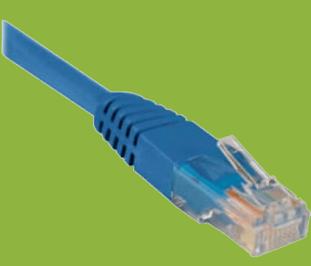

RJ48

It is a type of registered jack connector that uses a twisted wire pair of cables and an eight-pin modular jack for data communication interfaces. The RJ48 uses the same type of plug and socket as we used in the RJ45 connector, but the RJ48 uses a different type of pin-out, where one pair of pins is used to transmit the signal, another pair of pins is used for receiving the signal, another pair of pins is used for draining the signal, and one more pair of pins is left unused. The RJ48 cable is divided into three parts such as the RJ48-C, used for a surface mount like T1 lines and requires 1, 2, 4, and 5 pins. The RJ48-S uses 56 kbps for digital lines of wall mount that use pins 1, 2, 7, and 8. The RJ48-X is used for complex troubleshooting jack requiring 1, 2, 4 and 5 pins.

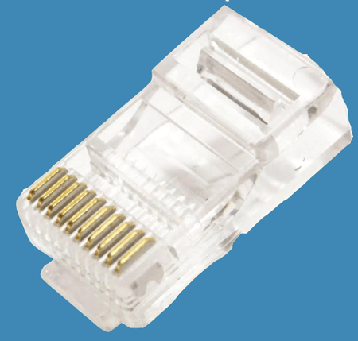

RJ61

It is the same as RJ11, but it uses 8P8C connector that means it has eight positions and eight conductors modular to connect with twisted-pair cables in the network devices.

Difference between RJ45 and RJ11

|  |  |  |
| --- | --- | --- |
| **Key Differences** | **RJ45** | **RJ11** |
| **Size** | The size of the RJ45 cable is wider. | The size of the RJ11 is smaller. |
| **Connected wires** | It has eight separate wires. | It has four connected wires. |
| **Usage** | It is used with Ethernet cable as well as telephone lines. | It is used in the telephone cable lines such as single, double or triple. |
| **Supported Bandwidth** | The transferring speed of data up to 10 Gbps over the Ethernet cable. | The transferring speed of the data in RJ11 is up to 24 Mbps. |
| **Connector** | It uses an 8P8C connector, where eight positions eight contacts modular. | It uses a 6P4C connector, where six positions four contacts modular. |

Characteristics of the RJ Cable:

1. It can work with configuring mounting surfaces for connecting voice and data equipment.
2. It is used with different telephone lines to share data over the registered jack connector.
3. There are many institutional academies, large organization, offices use RJ11, RJ12, RJ25, etc., because it can connect multiple telephone lines simultaneously.
4. It is also used to connect multiple computers using the Ethernet cable to share data over the local area network.
5. It can connect to cross-connections for more than two systems.

Advantages of the RJ Cable:

1. It is easy to install and configured with different devices.
2. It is a reliable cable, and the connection speed with the telecommunication interface is high.

Disadvantage of the RJ Cable:

1. It is only used for the shortest distance to connect with telecommunication devices.
2. Today most devices are wireless, so the use of registered jacks is becoming obsolete.
3. It has the limited mobility of the wire.